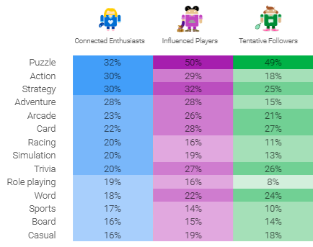

From our market research we came up with a concept of a puzzle memory game as it was the most prefered genre for the casual market.
On prototyping we discovered that a puzzle game that would have to follow the brief would not be as engaging and competetive as the brief suggests.
Instead we prototyped mechanics that would best suit the action and strategy genre, as the research suggests most players prefer within our target demograph. This would also fit to the brief as it has to be a competitive experience which puzzle games would find difficult to follow.
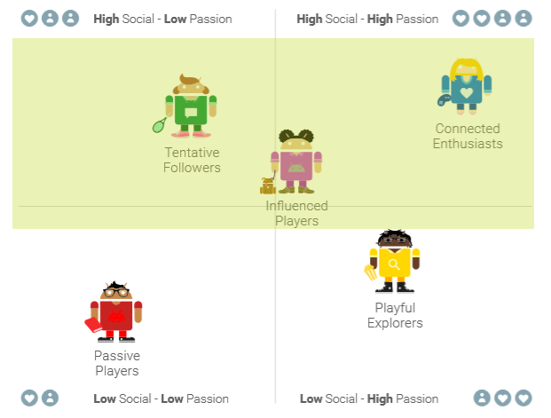
By this graphic we can show how our game concept fits into the Tenative Followers, Connected Enthusiasts and Infulenced Players demographics.
This is because our game concept features a high social interactitve experience with the aspects of low and high passion. This means players can enjoy the game through social interaction as well as being able to play for competion and a casual experience.
For our game we plan to focus primary on these demograhics.

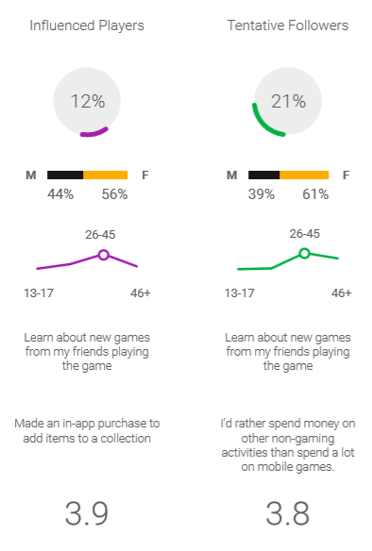
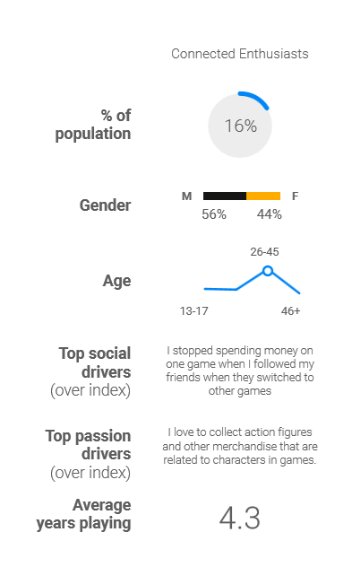

With further research into our chosen demographics we have a clear understanding of the age and gender of the players for each demographic. This will help us in our design when constructing the theme and art style that best suites them.

